Dara Rubin

Portfolio Plan

October 19, 2016

1. Audience and goals

My goal is for this to be something I can present to potential employers. I would like to work in magazine, both on the writing and print and web design side, so I am including both elements in my portfolio.

This portfolio is also for myself though, as a place to collect all the projects I’ve worked on.

2. Design Philosophy

My design philosophy is mostly simply and straightforward, but also a bit creative.

3. Projects I want to include:

Writing: cancellations, NASA or Time, current mag story eventually

(Videos: vaccines, election… undecided if I’ll include)

Interactive/Design: architecture story, first-gen, flyers

Magazine Design: Story spread, magazine spread, ipad pdfs??

Certificate Design: NU Day, LRSeat, Rock n’ Roller (videos and others)

Links to other sites I’ve built – innovation, rehearsoul

4. Setup

The home page will briefly introduce me and some of my skills. The navigation bar will take them to the various parts of my portfolio (it has a drop down for the different types of projects), an about me page with more/different info, my resume, and contact information. I chose the Bootstrap template Freelancer.

5. How the organization supports my philosophy

By dividing my portfolio section up into multiple categories, it keeps each page simple and prevents crowding, but the colors and overall design are what will make it more creative.

6. People to serve as reviewers:

Jill Blackman – She was my professor for my interactive storytelling class last quarter where we did a lot of web design. She has given great feedback on my past projects so I’m sure she’ll be very helpful with this. I already reached out to her and she’s happy to help.

Peter Haddad – He took design portfolio last year and so he knows what is expected and will give honest feedback.

Screen shots of current progress:

Bottom of home page

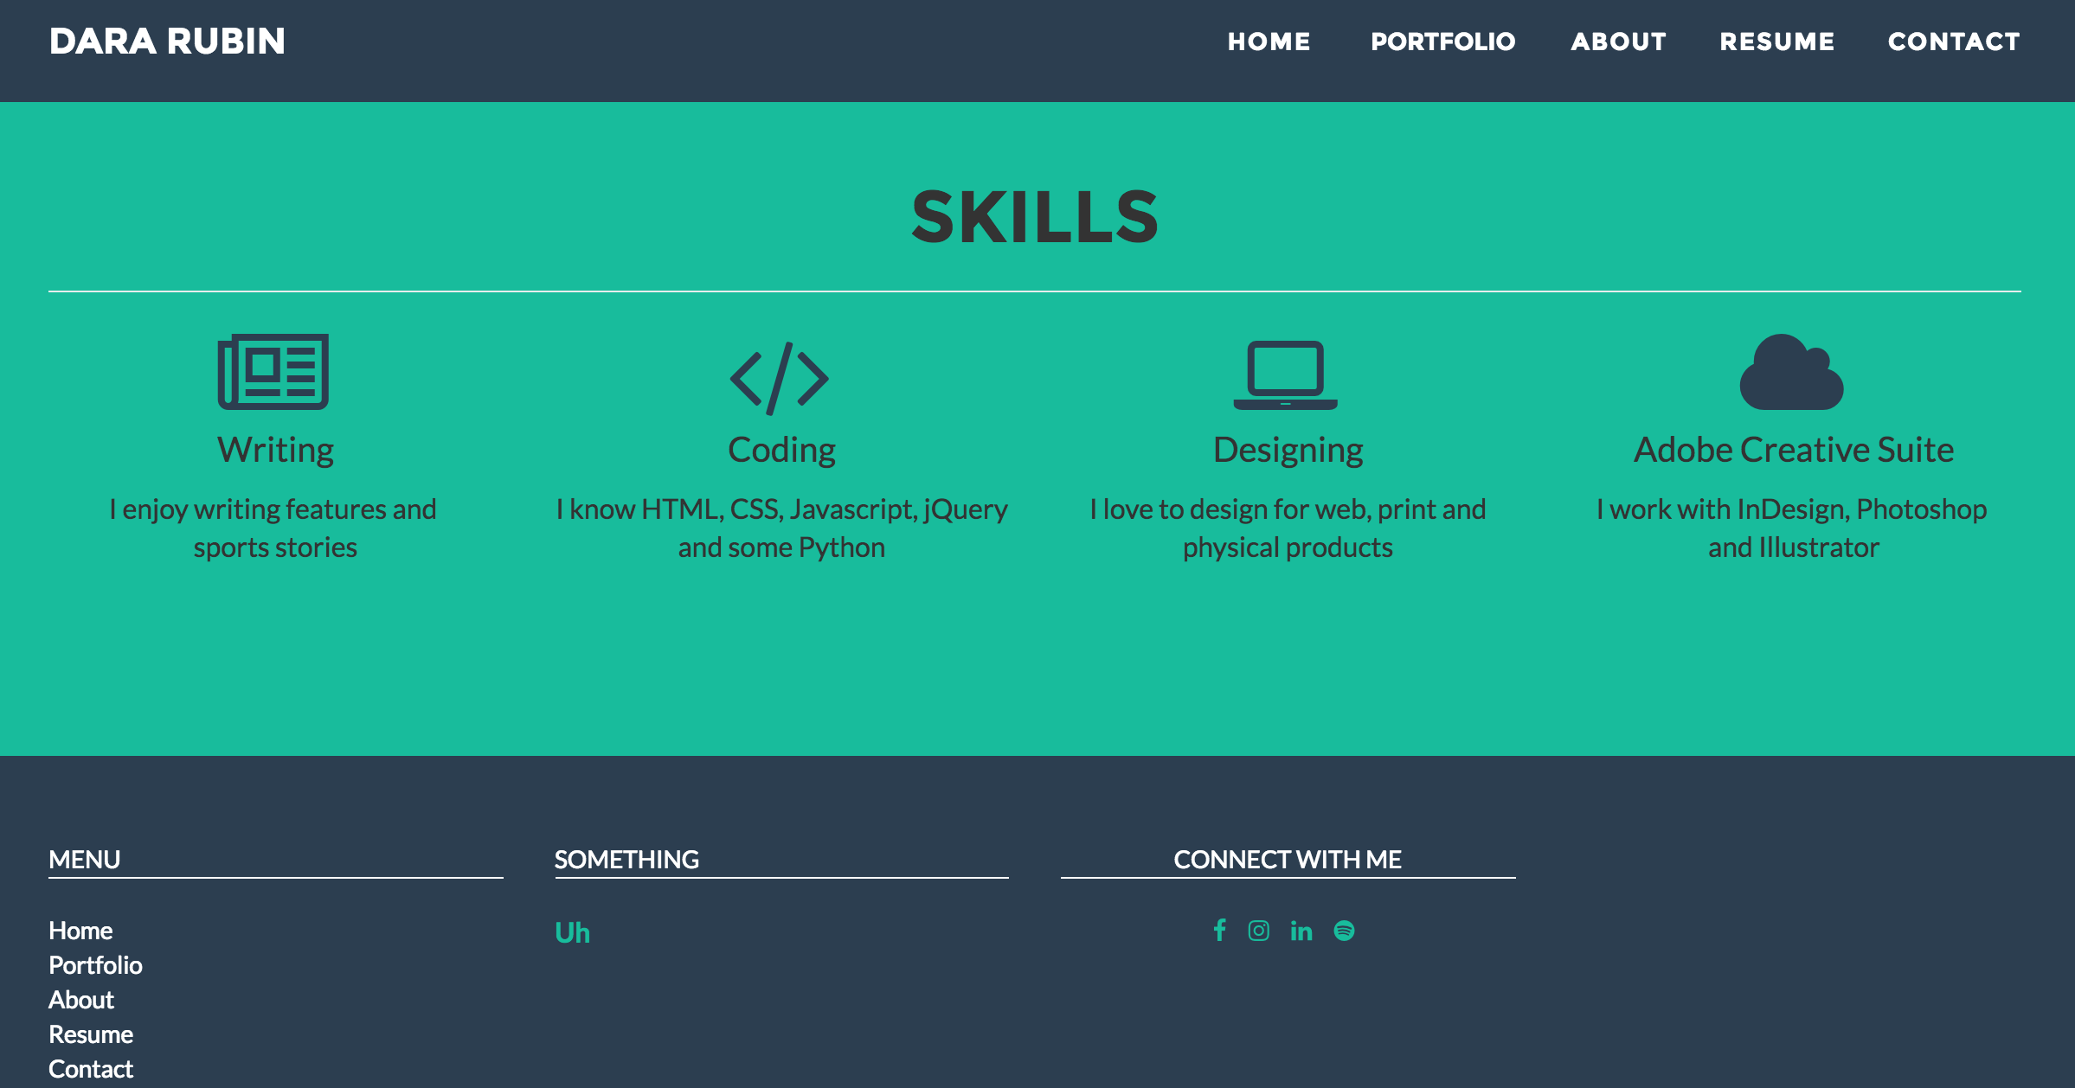

Portfolio: Stories

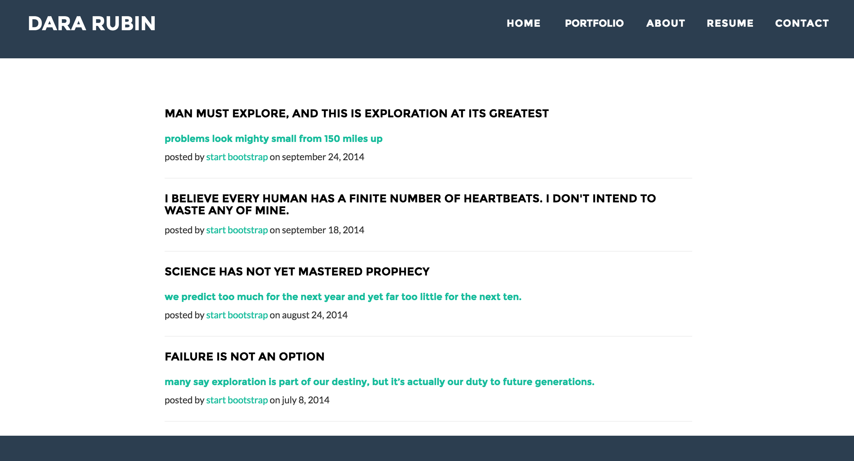

Portfolio: Videos

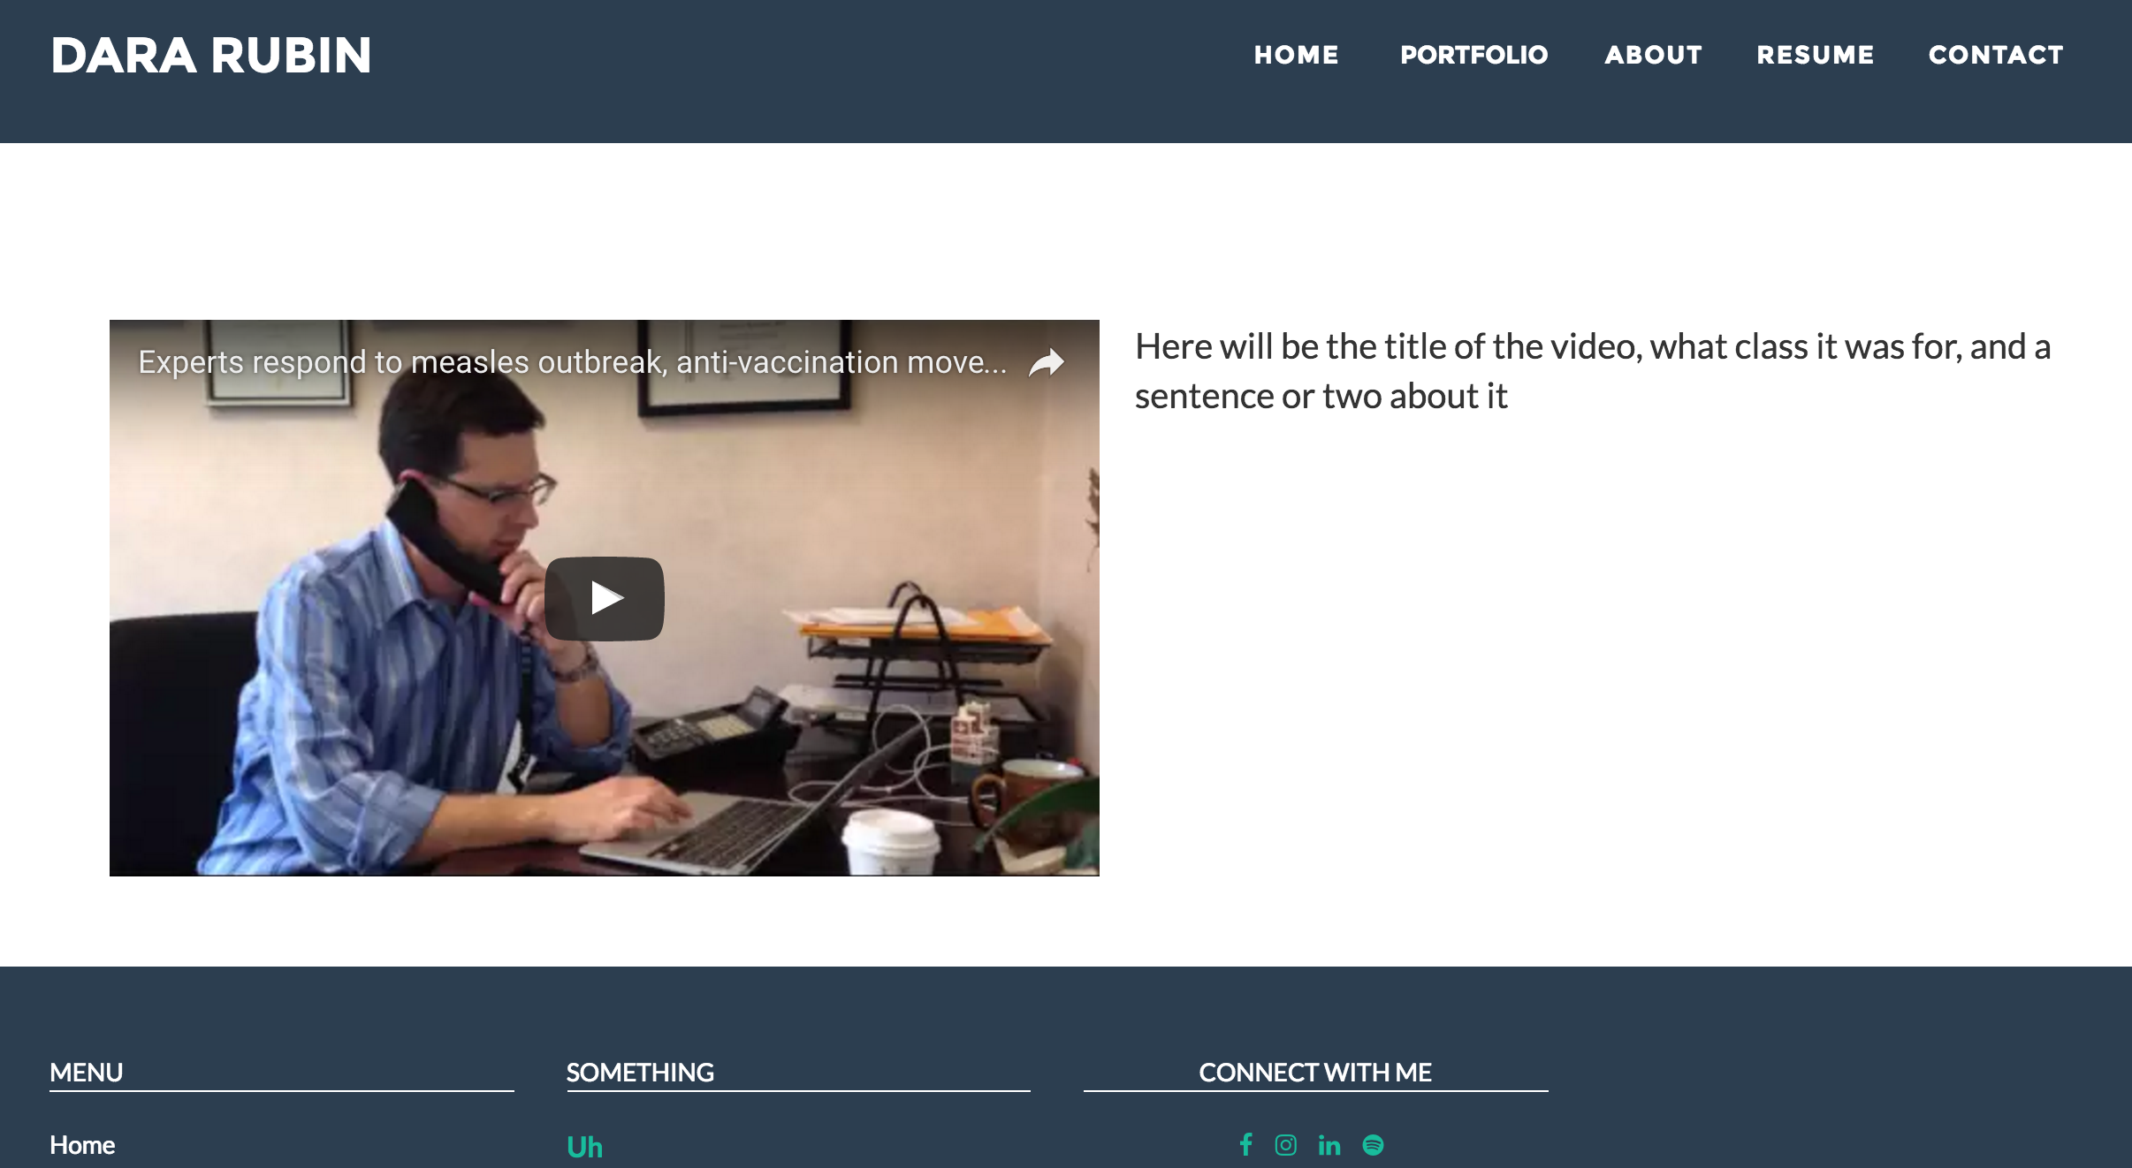  
Portfolio: Flyers

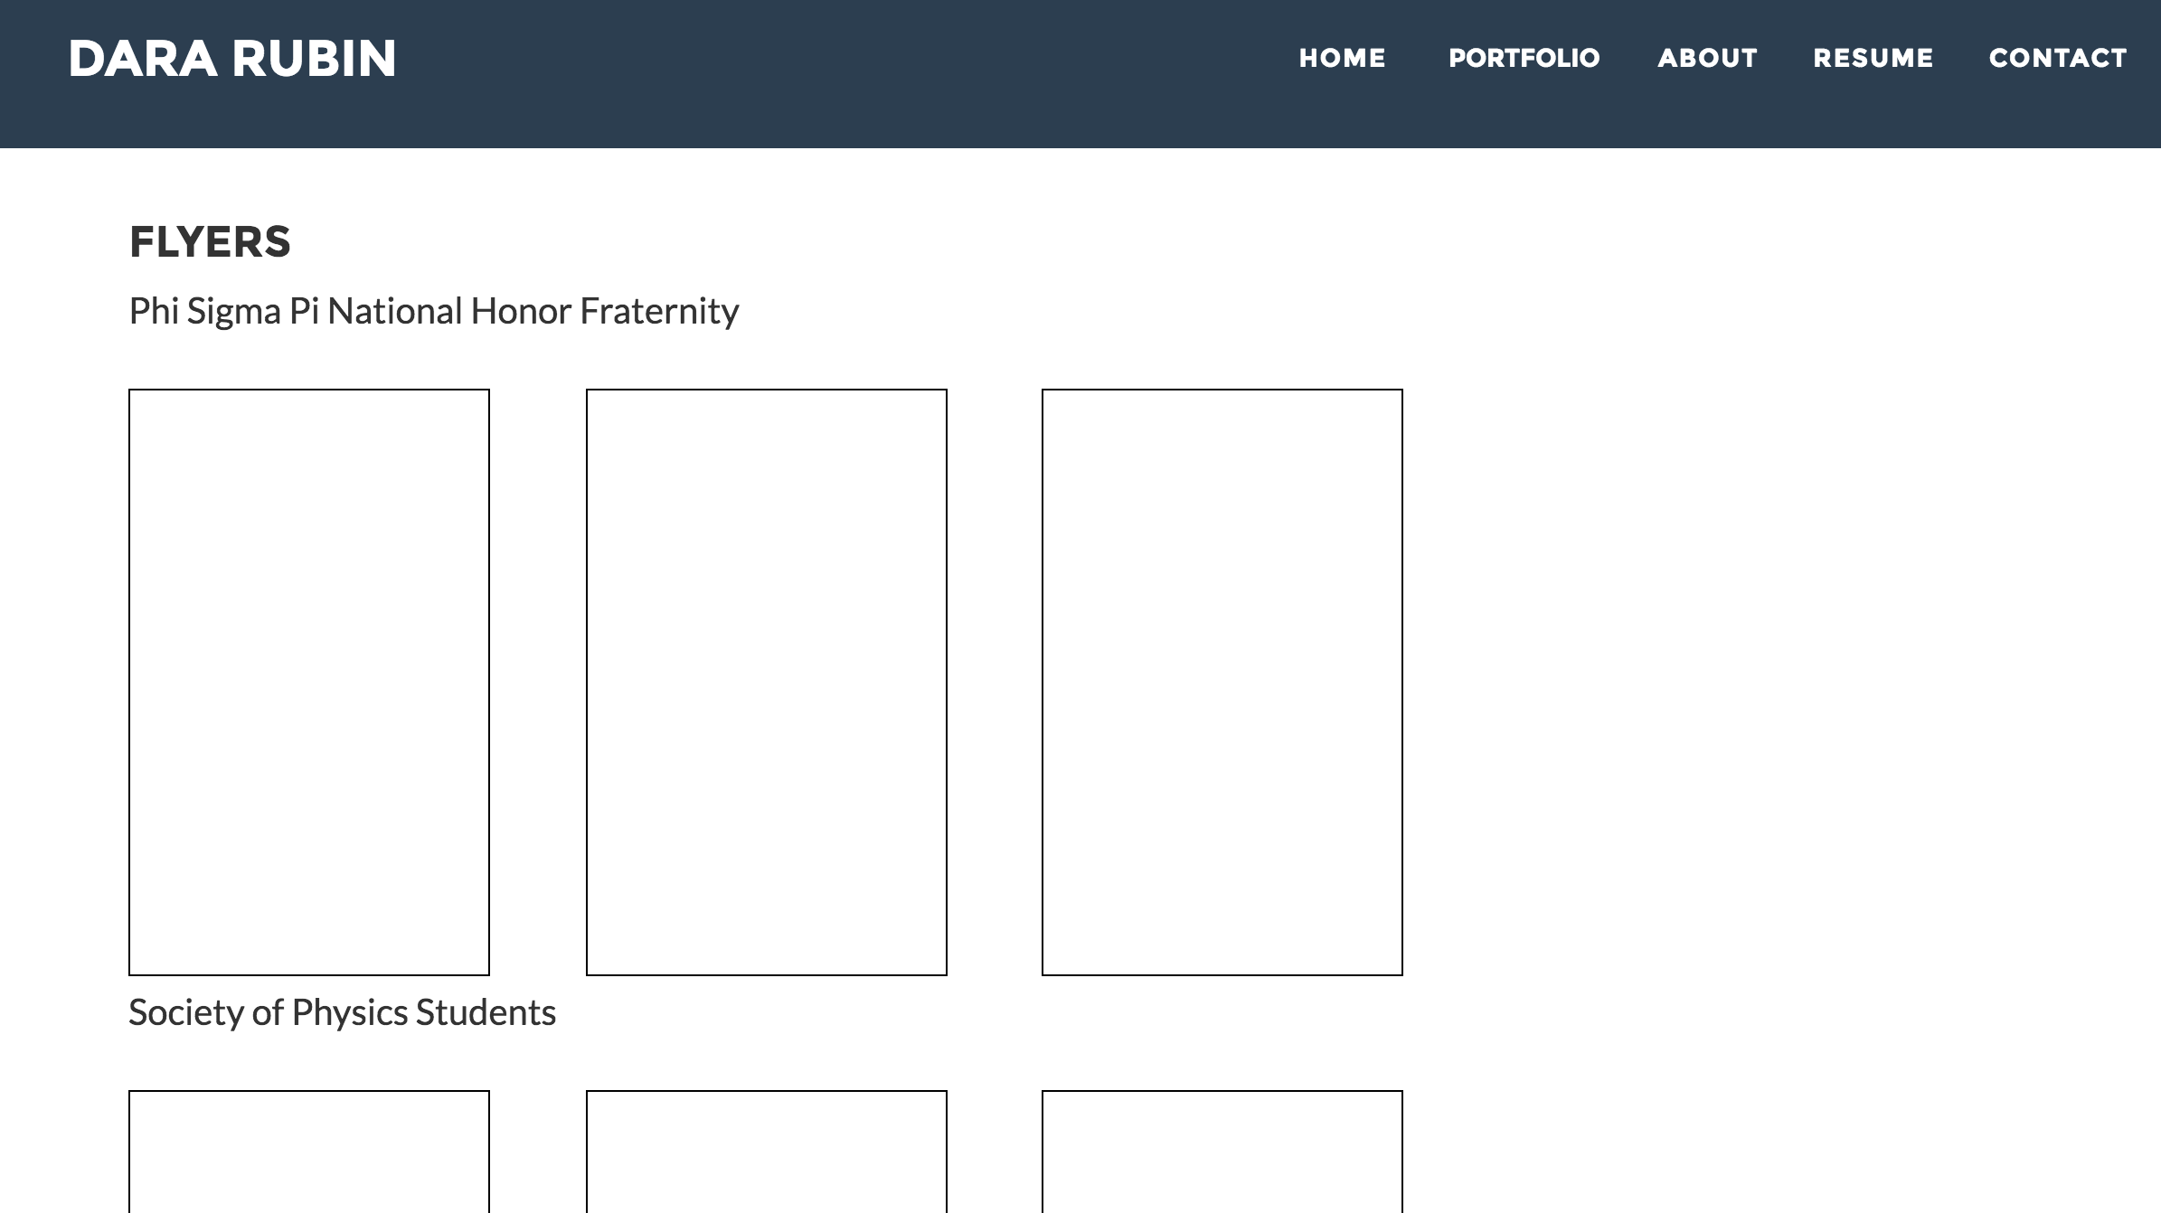

Portfolio: Design & Sketching:

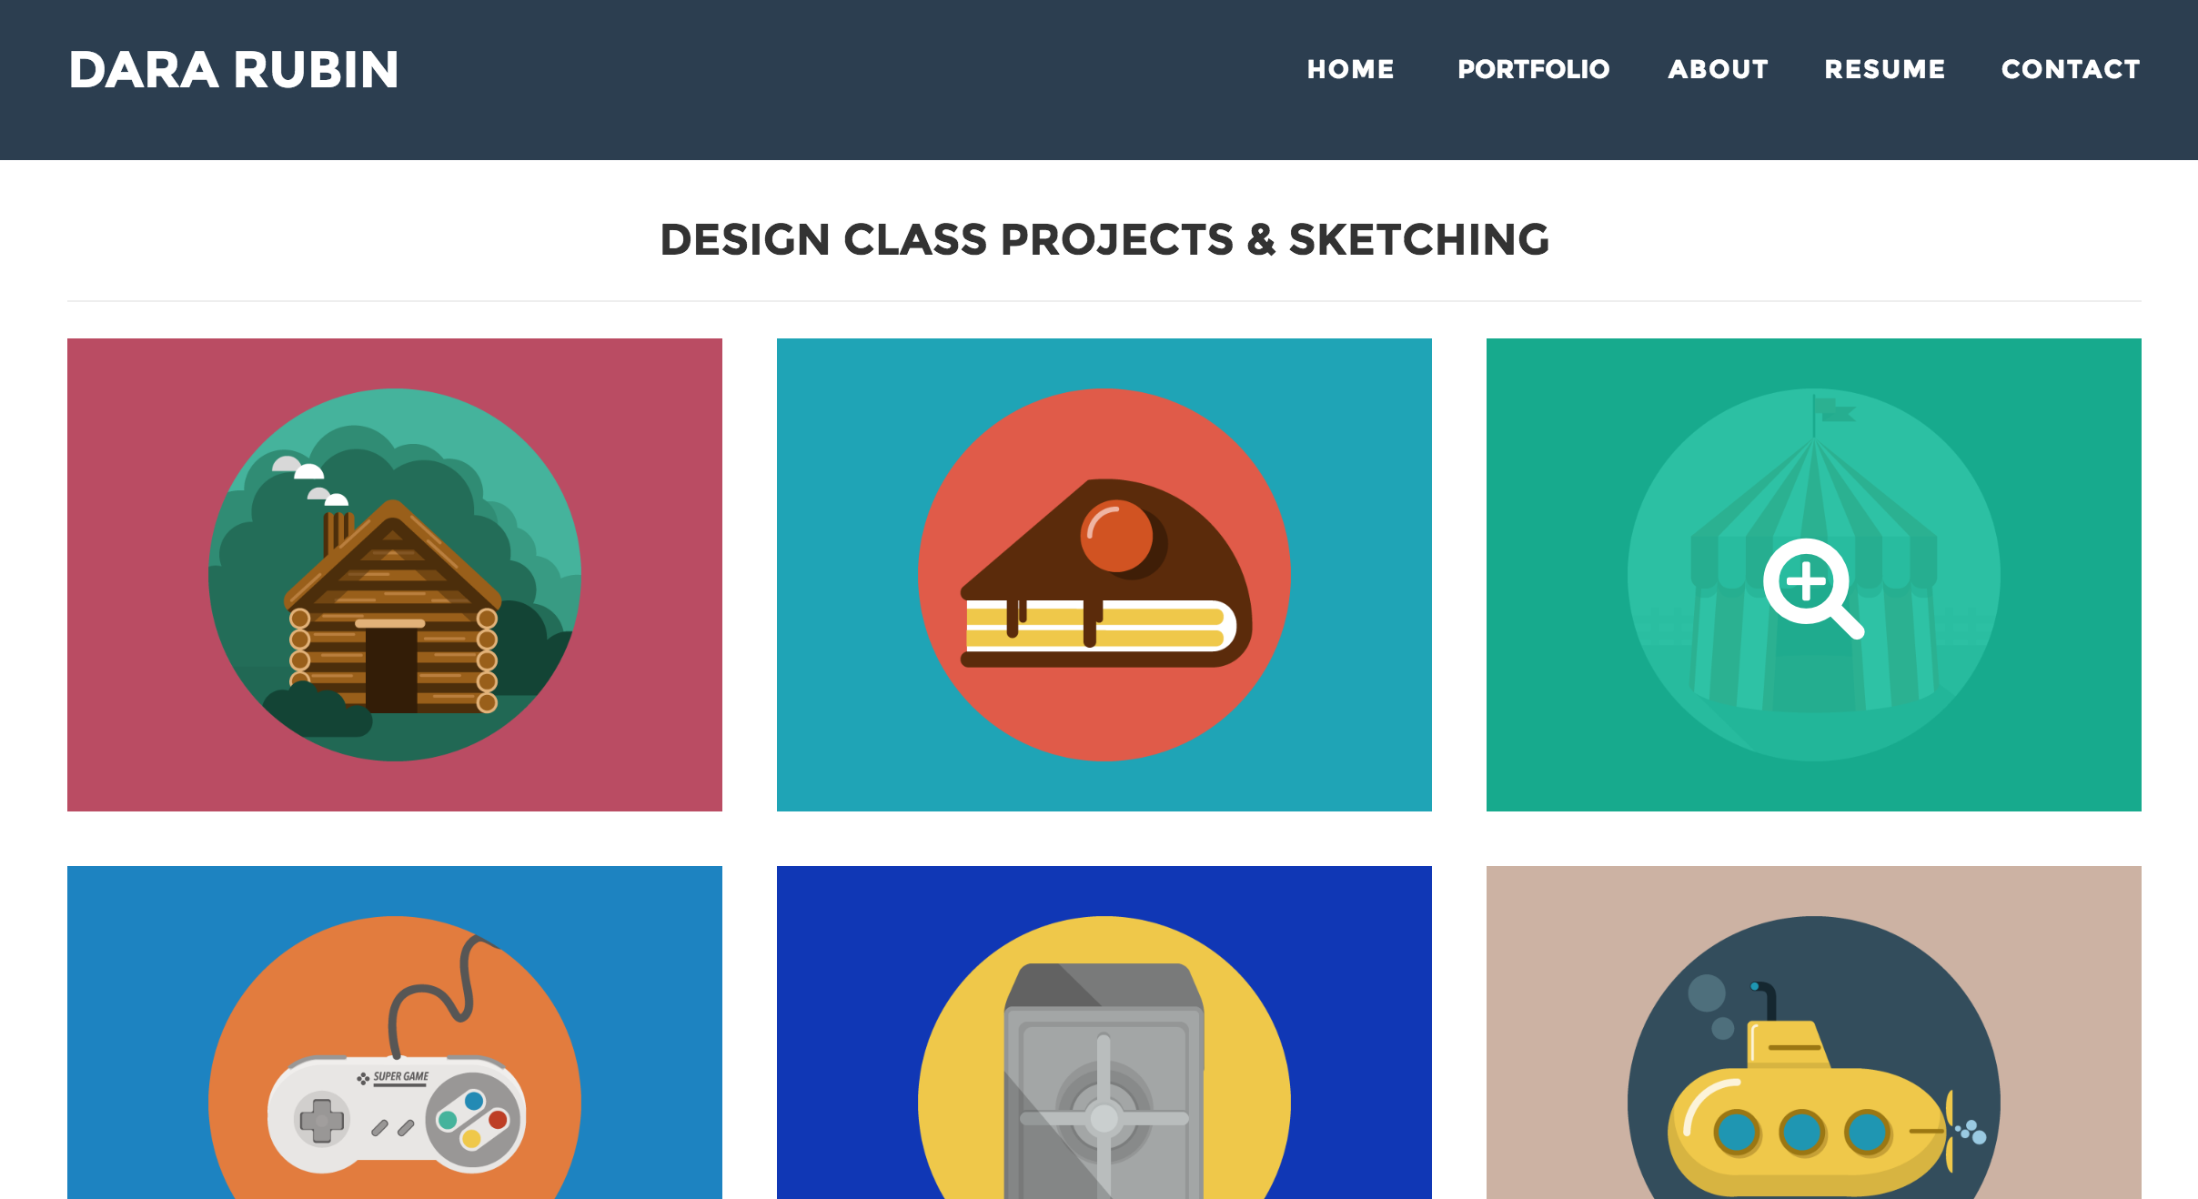

About page:

